**Azure App Services**

Case Study : Host the App services in the virtual machine deployed

Below are the screenshots of the steps followed.

Screenshot 1:

Creating a VM.

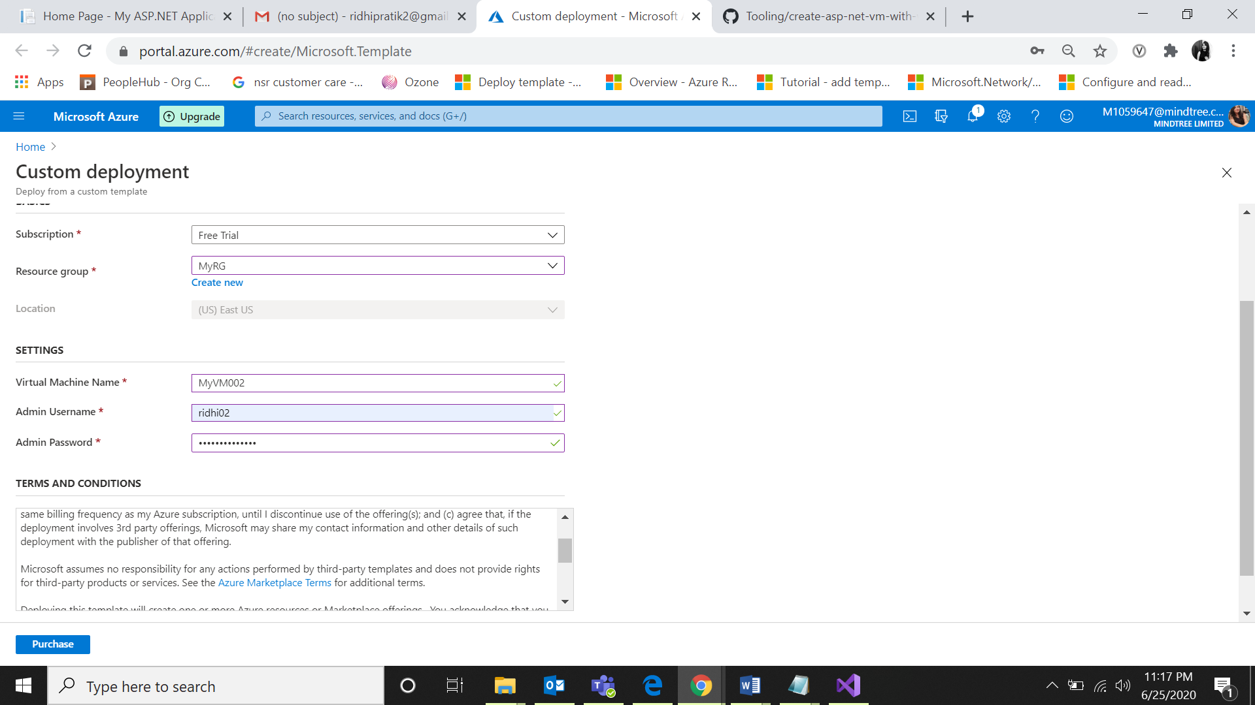Screenshot 2:

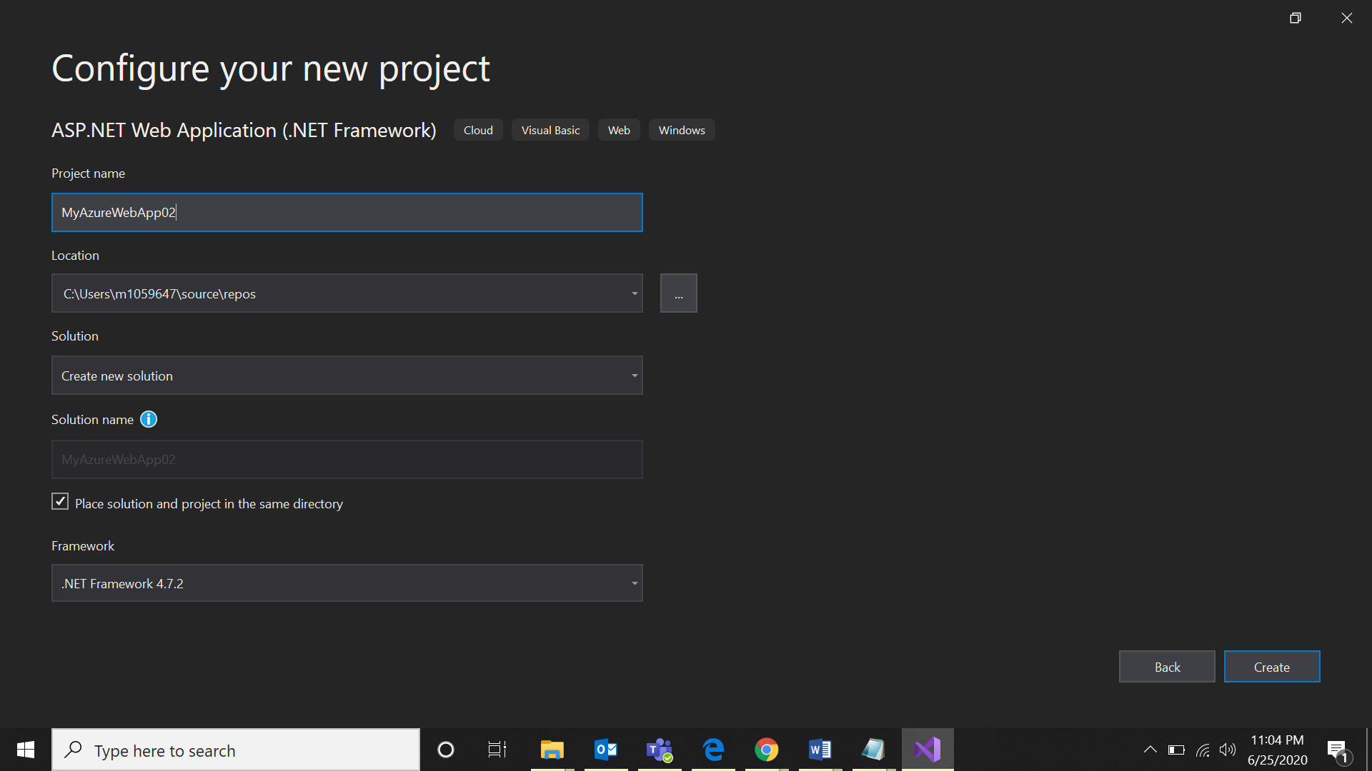

Screenshot 3:

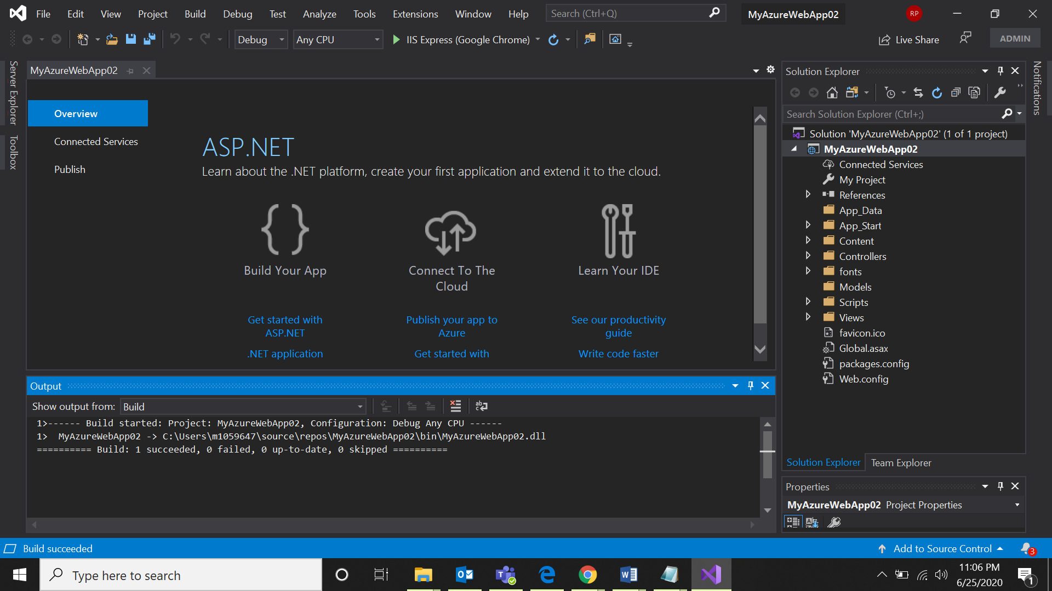

Screenshot 4:

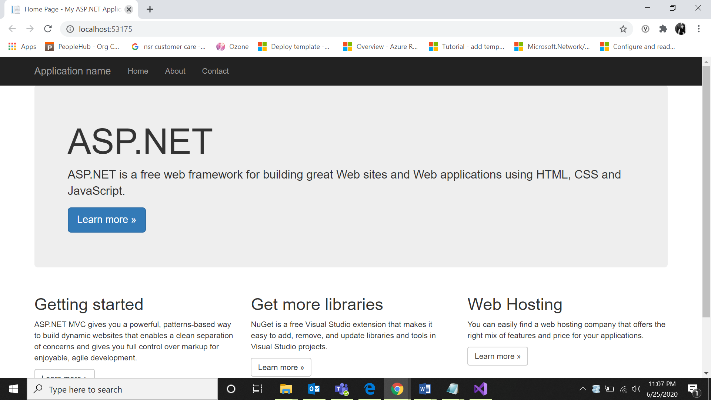

Screenshot 5:

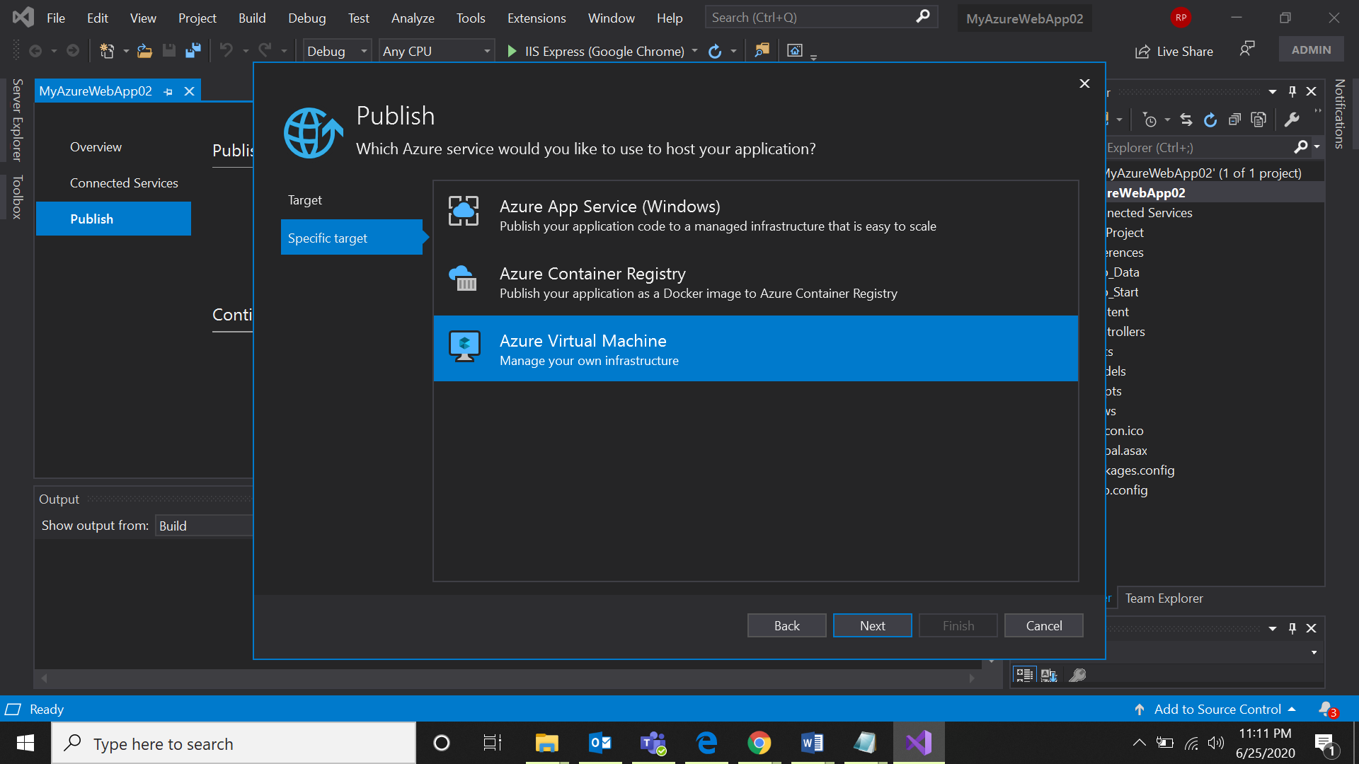

Screenshot 6:

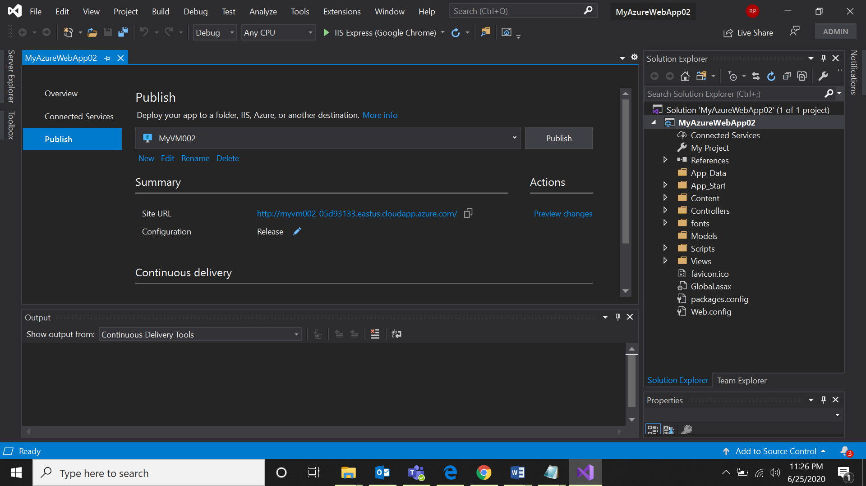

Screenshot 7:

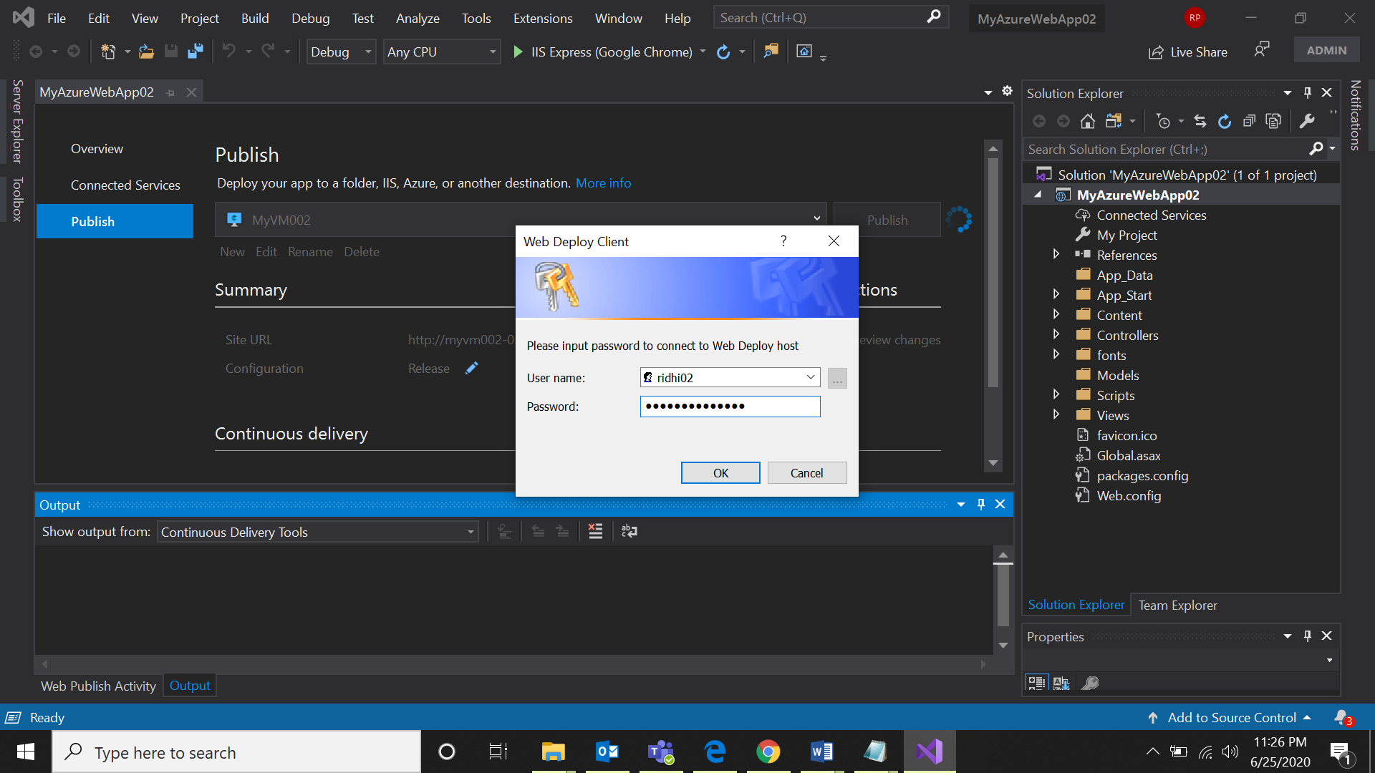

Screenshot 8:

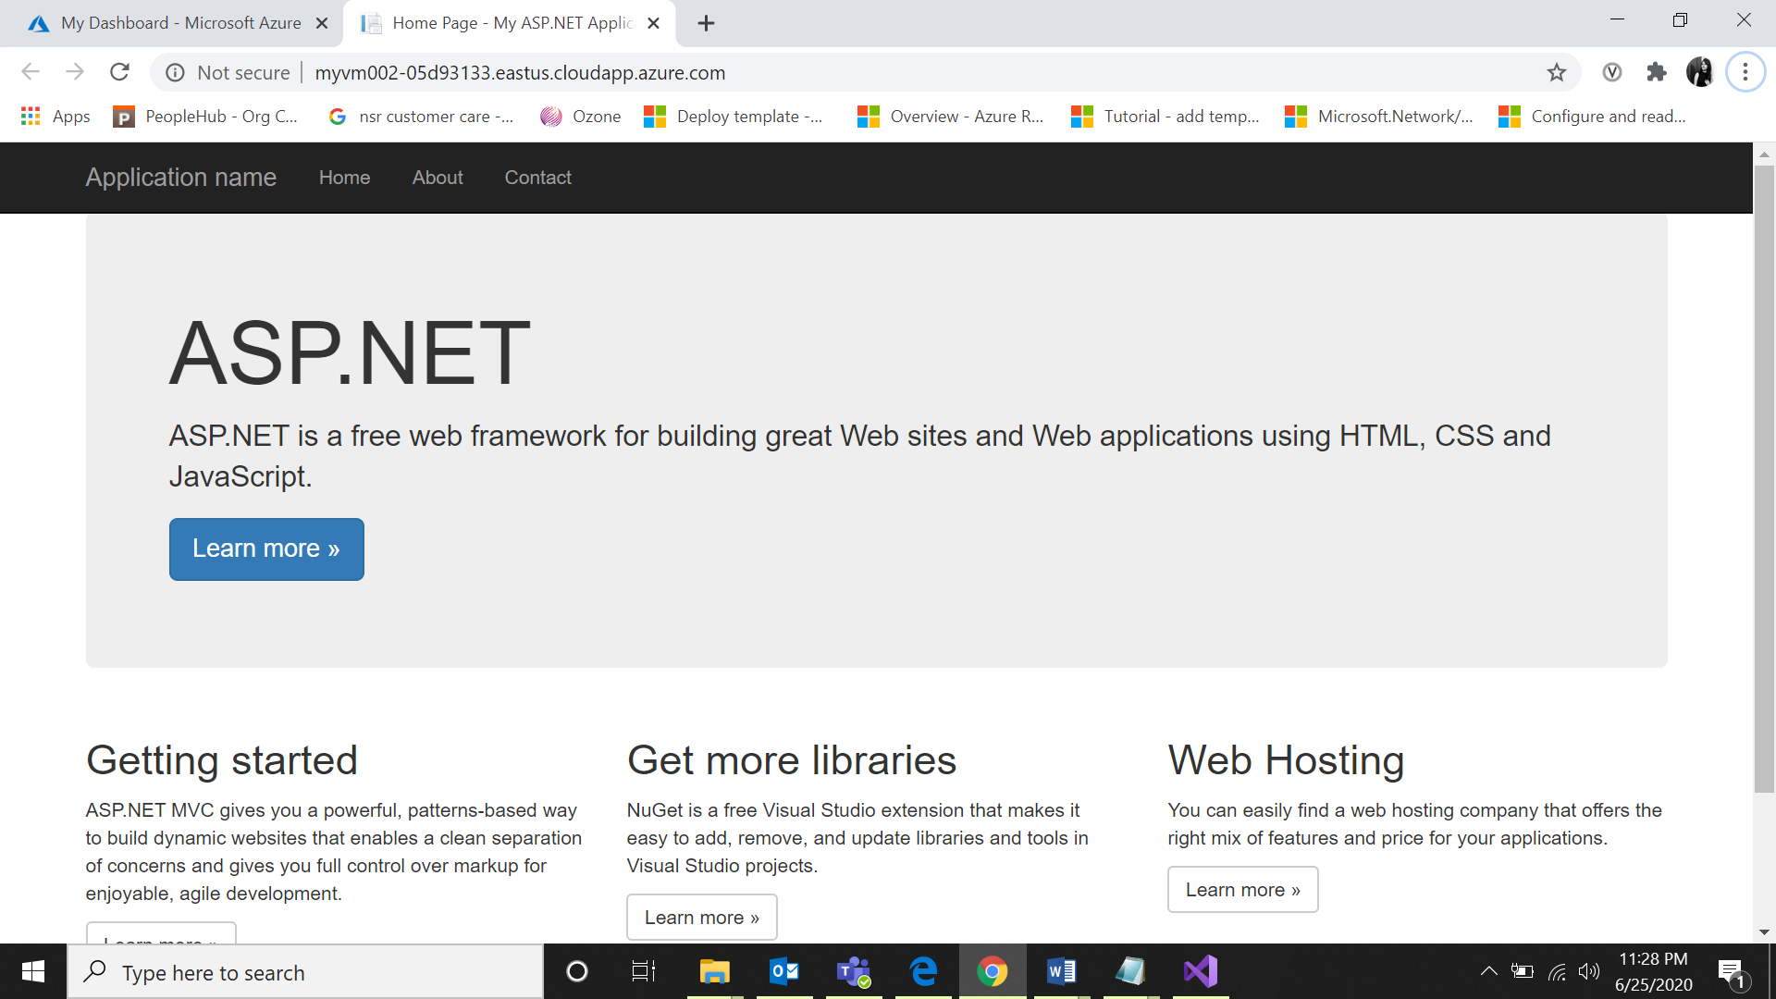

Screenshot 9:

